**Lab Exercise 11- Deployments with Rolling Update and Recreate Strategies**

**Name: Arin Agrawal**

**SAP ID:500120660**

**Roll no: R2142230502**

**Batch: Devops B1**

Understand how to use the rolling update and recreate strategies for deploying applications using Kubernetes Deployments.

**Step 1: Create a Deployment with Rolling Update Strategy**

Create a YAML file for the deployment:

Create a file named **nginx-deployment-rolling.yaml** with the following content:

apiVersion: apps/v1

kind: Deployment

metadata:

name: nginx-deployment-rolling

spec:

replicas: 10

minReadySeconds: 10

selector:

matchLabels:

app: web

strategy:

type: RollingUpdate

rollingUpdate:

maxUnavailable: 1

maxSurge: 5

template:

metadata:

labels:

app: web

spec:

containers:

- name: nginx

image: hkshitesh/kubedemo:1.0

ports:

- containerPort: 80

Apply the deployment:

kubectl apply -f nginx-deployment-rolling.yaml ; watch "kubectl get rs -o wide"

Verify the deployment:

kubectl get deployments

kubectl get pods -l app=web

Update the deployment to a new image:

kubectl set image deployment/nginx-deployment-rolling nginx= hkshitesh/kubedemo:2.0

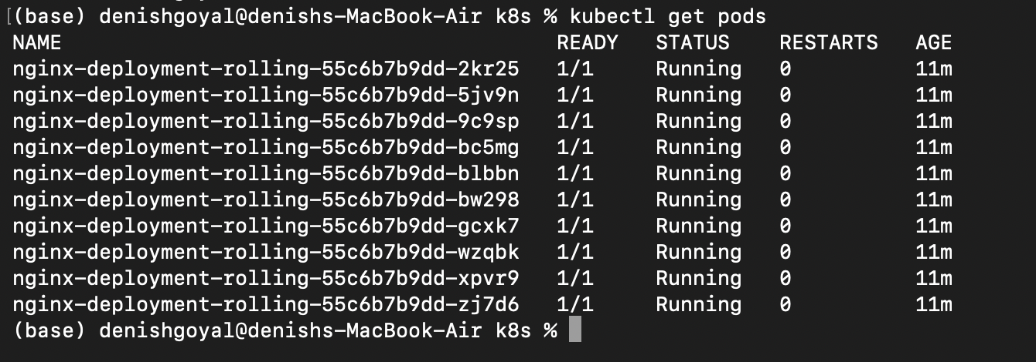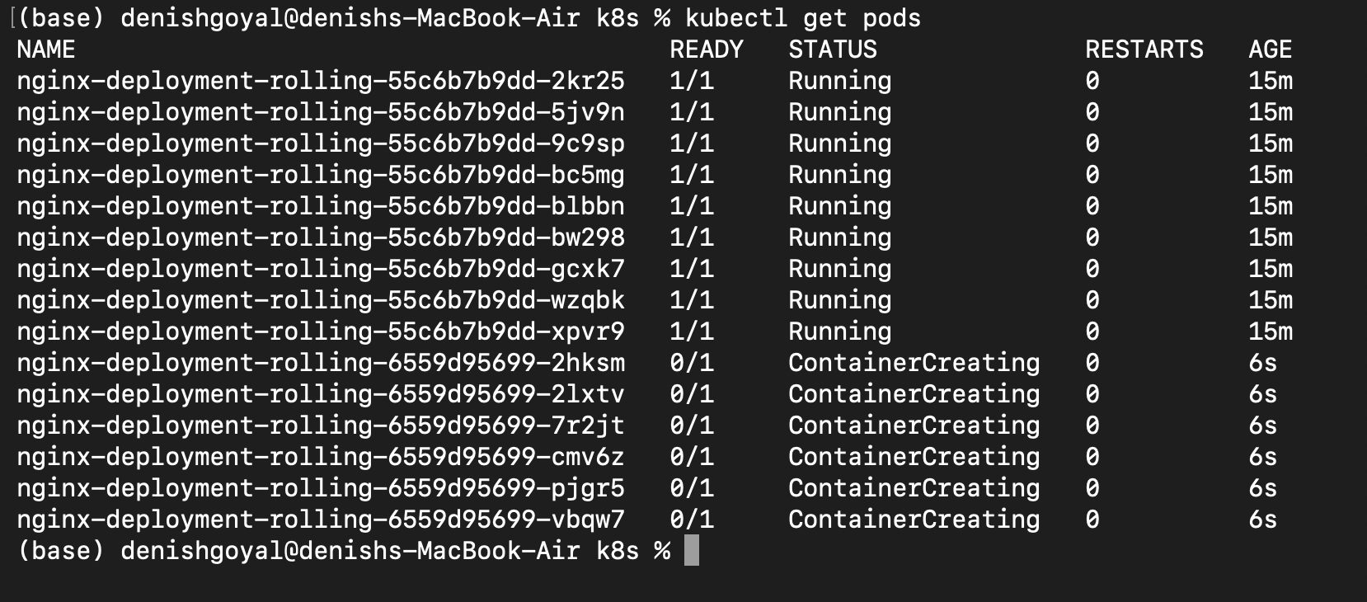

Monitor the rolling update:

kubectl rollout status deployment nginx-deployment-rolling

Verify the updated pods:

kubectl get pods -l app=web -o wide

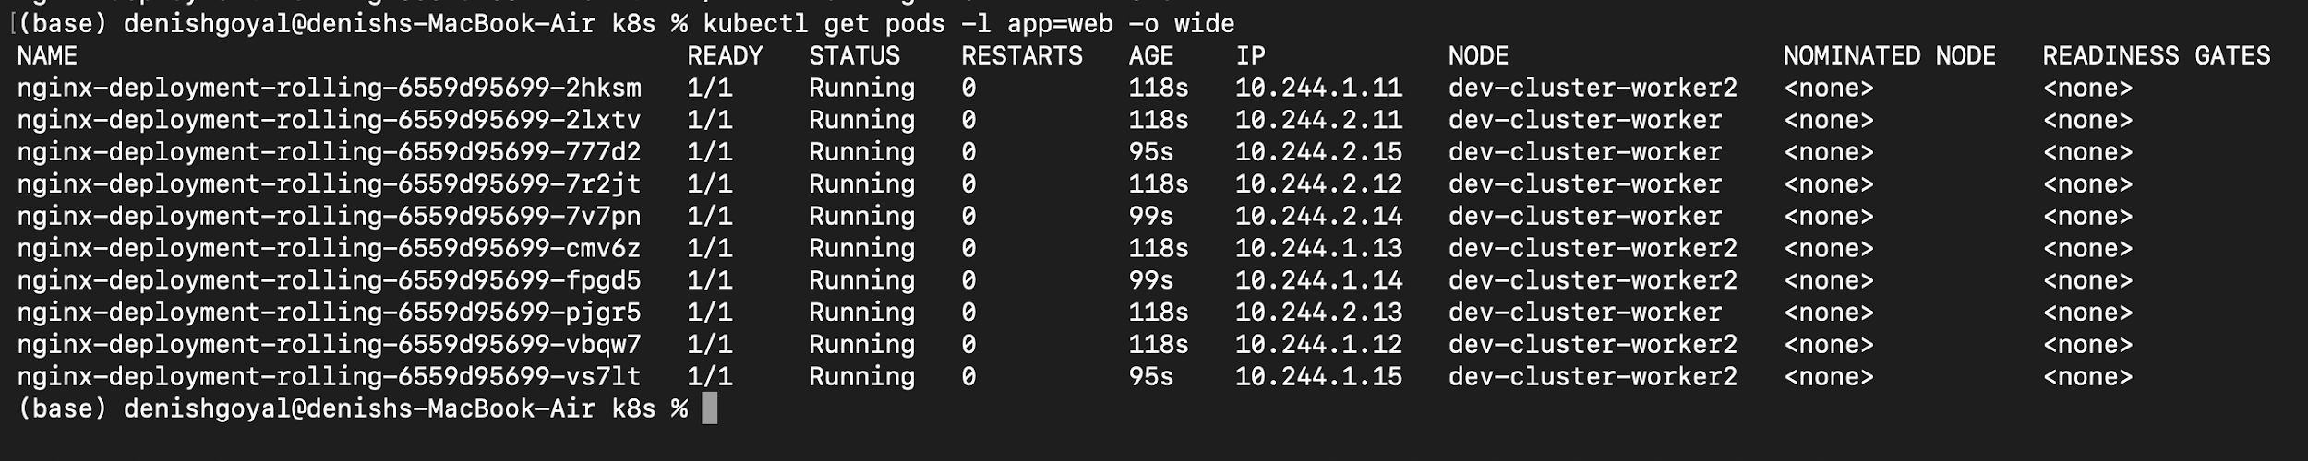

**Step 2: Create a Deployment with Recreate Strategy**

Create a YAML file for the deployment:

Create a file named **nginx-deployment-recreate.yaml** with the following content:

apiVersion: apps/v1

kind: Deployment

metadata:

name: nginx-deployment-recreate

spec:

replicas: 10

selector:

matchLabels:

app: web

strategy:

type: Recreate

template:

metadata:

labels:

app: web

spec:

containers:

- name: nginx

image: nginx: hkshitesh/kubedemo:1.0

ports:

- containerPort: 80

Apply the deployment:

kubectl apply -f nginx-deployment-recreate.yaml ; watch "kubectl get rs -o wide"

Verify the deployment:

kubectl get deployments

kubectl get pods -l app=nginx-recreate

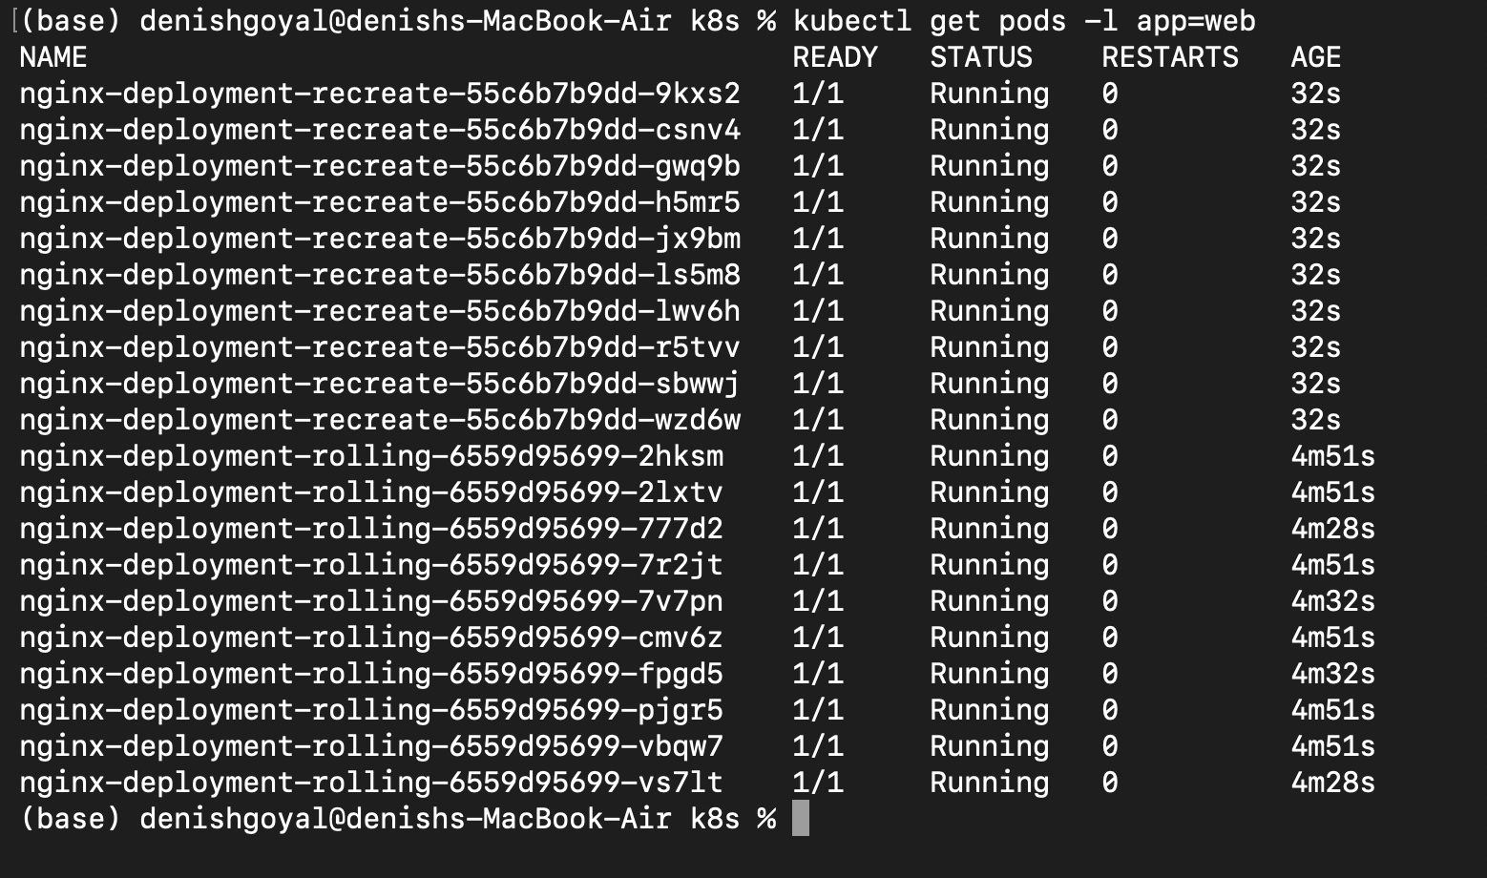

Update the deployment to a new image:

kubectl set image deployment/nginx-deployment-recreate nginx=nginx:1.21.1

Monitor the update:

kubectl rollout status deployment nginx-deployment-recreate

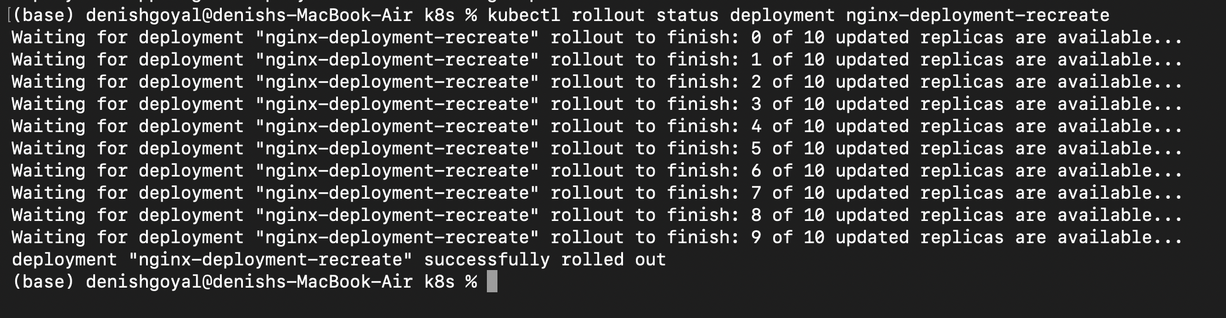

Verify the updated pods:

kubectl get pods -l app=nginx-recreate -o wide

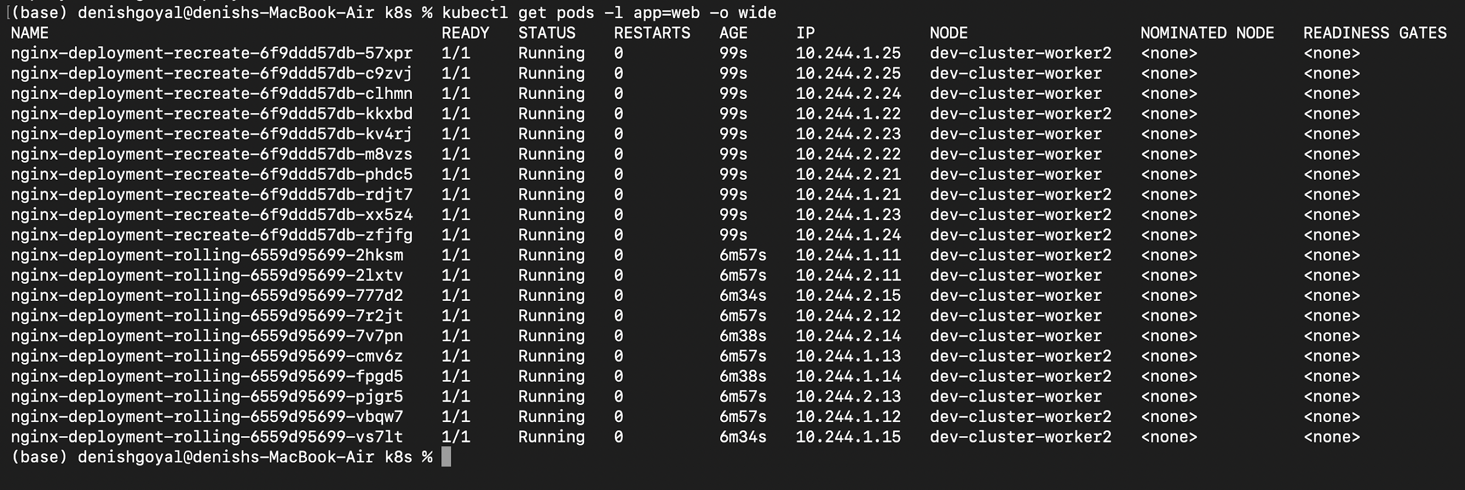

**Step 3: Clean Up**

Delete the deployments:

kubectl delete deployment nginx-deployment-rolling

kubectl delete deployment nginx-deployment-recreate

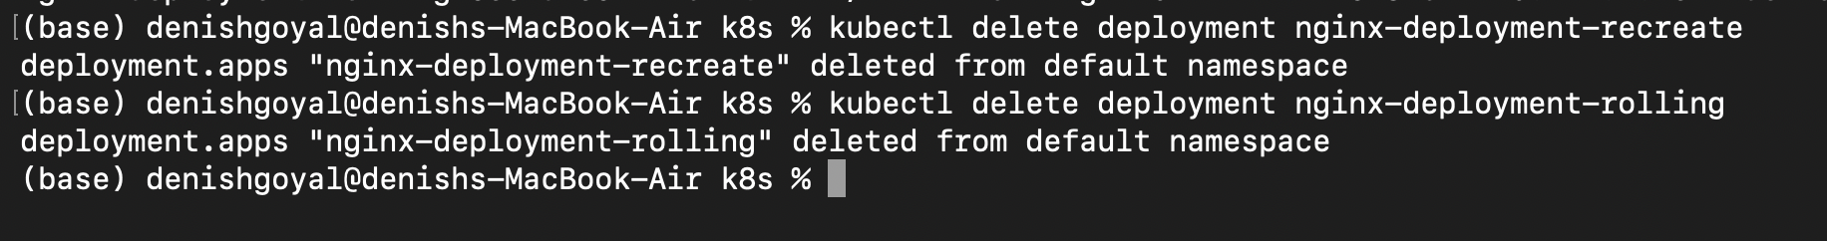

Verify that all resources are cleaned up:

kubectl get deployments

kubectl get pods -l app=nginx

kubectl get pods -l app=nginx-recreate